**Library Management System**

**Database Diagram:**

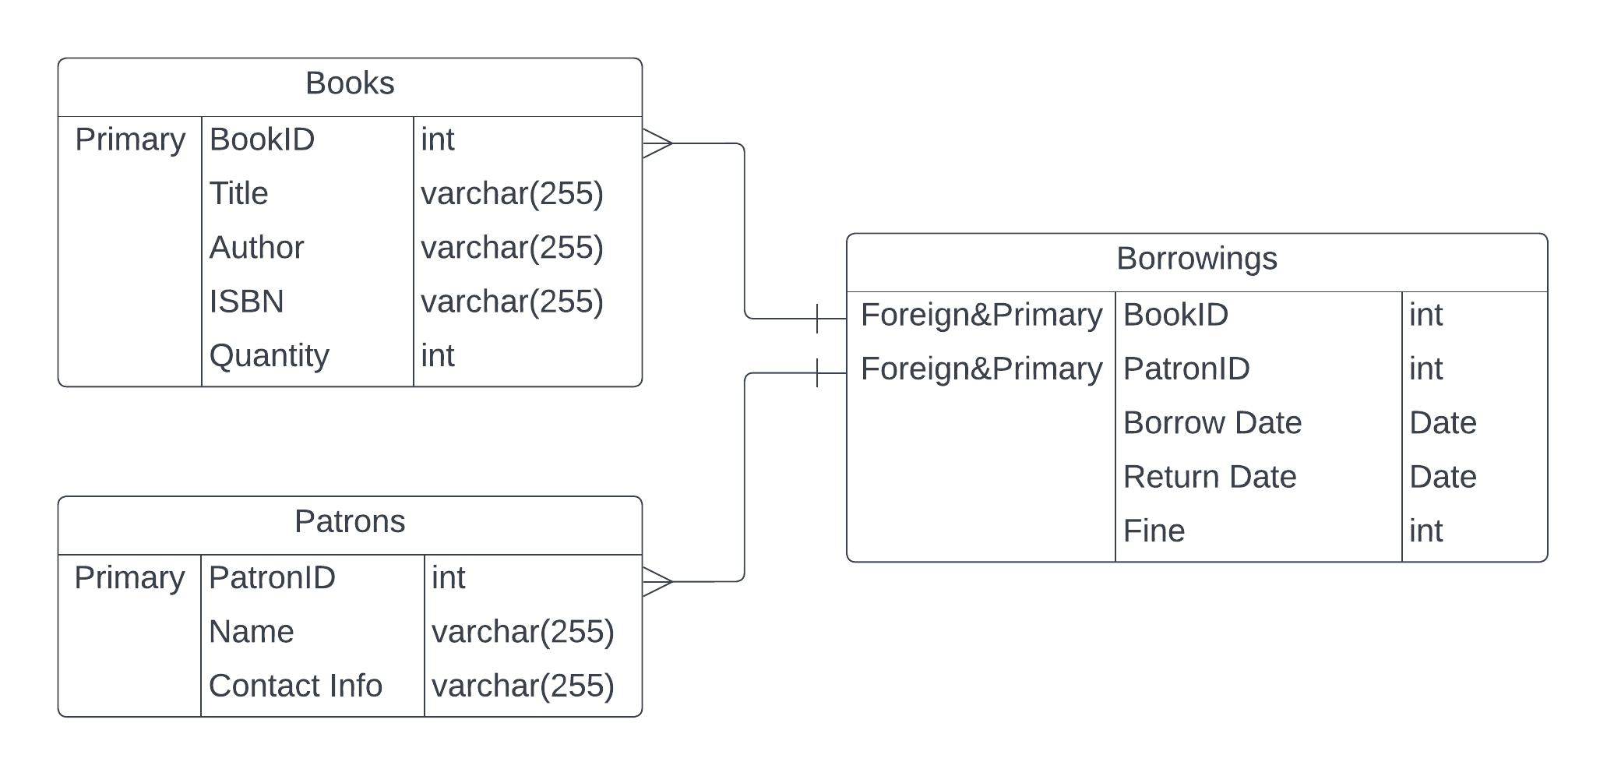

BookID and PatronID are primary keys for their respective tables.

BookID(Borrowings) is a foreign key to the Books Table(BookID) and PatronID(Borrowings) is a is a foreign key to the Patrons Table(PatronID)

Borrowings is a many-to-many table between Patrons and Books. Borrowings doesn’t have an id because it wouldn’t be normalized as good as having a composite primary key made of the 2 foreign keys from the many-to-many relationship. Every attribute in the Borrowings table is functionally dependent on and results from the composite primary key. It meets every requirement for being a Boyce-Codd Normal Form.

There should also be a trigger or a default constraint on a row for Patrons called “amount” or something like that to check how many books he can borrow.

**Class Diagram:**

**Relationships:**

- A one-to-many relationship between Book and Borrowing (a single book can be part of many borrowing records, but each borrowing record refers to one unique book).

- A one-to-many relationship between Patron and Borrowing (a single patron can have many borrowing records, but each borrowing record refers to one unique patron).

- An association class, Borrowing, linking Book and Patron, signifying the many-to-many relationship and holding the attributes of the association like Borrow Date, Return Date, and Fine.

borrowBook() method also returns a Boolean flag showing if Patron can borrow more books or is at his limit.

